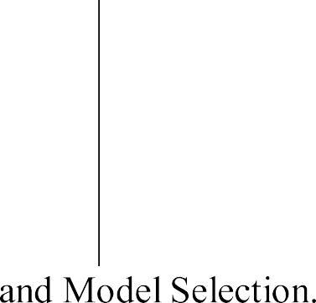



|  |  |
| --- | --- |
|  |  |
|  |  |

|  |  |  |  |  |
| --- | --- | --- | --- | --- |
|  | **GOUTHAM GANESH SHANBHAG**  **(20BBTCS047)** | **JOGINDER PRATHAP SINGH N**  **(20BBTCS061)** | **JOMI THOMAS**  **(20BBTCS062)** | **K HARSH MOHAN**  **(20BBTCS063)** |



|  |  |  |  |  |
| --- | --- | --- | --- | --- |
|  |  | | | |
|  |  | | | |
|  |  | |  |  |
|  |  | | |  |
|  |  | | | |
|  |  | | | |
|  |  |  | |  |
|  |  | | | |

|  |  |
| --- | --- |
|  |  |
|  |  |

|  |  |  |  |
| --- | --- | --- | --- |
|  |  |  |  |



|  |  |  |  |  |
| --- | --- | --- | --- | --- |
|  |  | | | |
|  |  | | | |
|  |  | |  |  |
|  |  | |  |  |
|  |  | | | |
|  |  | | | |
|  |  |  | |  |
|  |  | | | |

|  |  |  |  |
| --- | --- | --- | --- |
|  |  |  |  |



|  |  |  |  |  |
| --- | --- | --- | --- | --- |
|  |  | | | |
|  |  | | | |
|  |  | |  |  |
|  |  | |  |  |
|  |  | | | |
|  |  | | | |
|  |  |  | |  |
|  |  | | | |

|  |  |  |  |
| --- | --- | --- | --- |
|  |  |  |  |



|  |  |  |  |  |
| --- | --- | --- | --- | --- |
|  |  | | | |
|  |  | | | |
|  |  | |  |  |
|  |  | |  |  |
|  |  | | | |
|  |  | | | |
|  |  |  | |  |
|  |  | | | |